Economic instruments for supplying agrobiodiversity conservation

**Warwick Wainwright**

Doctor of Philosophy – The University of Edinburgh – 2018

Declaration

I, Warwick Wainwright, declare that:

1. This thesis was composed by myself
2. The work contained herein is my own, except where clearly stated
3. The work has not been submitted for any other degree or professional qualification
4. Included publications are my own work

Signed: ____________________

Dated: _________________

Abstract

Graphical abstract

Lay summary

Acknowledgements

I would like to express my thanks to my supervisors Professor Dominic Moran (SRUC) and Professor Geoff Simm (University of Edinburgh) for all their guidance and support.

Thanks also goes too Adam Drucker (Bioversity International), Alistair McVittie (SRUC), Bouda Ahmadi (SRUC), Faical Akaichi (SRUC), Klaus Glenk (SRUC), Libby Henson (Grassroots) and Tom Beeston (Rare Breeds Survival Trust), for their continued support and assistance with fieldwork.

I would also like to acknowledge funding for this PhD project provided by the Natural Environment Research Council (NERC) E3 Doctoral Training Programme (DTP). I also acknowledge funding from Operation Wallacea and the SADC Crop Wild Relatives Project (FED/2013/330-210) co-funded by the European Union and implemented through ACP-EU Co-operation Programme in Science and Technology. I also acknowledge the support of the Scottish Government’s Rural and Environment Science and Analytical Services Division (RESAS) funding to SRUC.

Finally, I wish to thank my family, Aaron, Hadley, Clive and Heather Wainwright for putting up with me.

Table of Contents

Economic instruments for supplying agrobiodiversity conservation 1

List of abbreviations 1

Author’s contribution to the field 1

Introduction 1

1.1 Global livestock production 1

1.2 What are Farm Animal Genetic Resources (FAnGR) 1

1.3 The importance of FAnGR 2

1.4 The state of FAnGR globally 3

1.5 Aims and objectives 3

1.6 Structure of the thesis 3

Valuing rare livestock breeds and farm animal genetic diversity: preferences, institutions and prospects 4

2.1 4

Contracts for supplying Farm Animal Genetic Resources (FAnGR) conservation services in Romania 4

Economic costs for in-situ conservation of Crop Wild Relatives (CWR) in Zambia: An application of Competitive Tender (CT) 5

Developing a prioritisation metric for conserving cattle native breeds at risk (NBAR) in the UK 5

Conclusion and recommendations 6

References 6

Appendix 6

List of abbreviations

Author’s contribution to the field

Chapter one

# Introduction

## Global agricultural production

### Livestock production

The global livestock sector is estimated to account for 33% of agricultural Gross Domestic Product (GDP); employs 1.3 billion people and occupies some 30% of the planets ice-free surface (Steinfeld et al., 2007; Thornton, 2010). Livestock production’s environmental footprint is a cause for concern and has now come to the fore of global environmental governance and climate change discourse. Since 2000 it is estimated the livestock sector alone occupied 52% of humanity’s safe operating space for anthropogenic greenhouse gas (GHG) emissions (Pelletier and Tyedmers, 2010). At the same time, global production of meat is projected to more than double from 229 million tonnes in 1999/01 to 465 million tonnes in 2050 whilst milk production is expected to grow from 580 to 1,043 million tonnes (Steinfeld *et al.*, 2007).

Rising consumption of livestock products is particularly evident in developing countries, owing to growing populations, rising incomes and changing consumer preferences (Godfray et al., 2010). There is therefore a need to increase output to meet growing demand. In parallel, the environmental impact per unit of livestock must be significantly reduced to avoid increasing environmental degradation (Pelletier and Tyedmers, 2010). This means increasing efficiencies per animal, whereby future livestock breeding programmes will arguably play a pivotal role. In this context, farm animal genetic resources (FAnGR) can make a significant contribution to improving the sustainability of livestock production (Eisler et al., 2014).

### Crop production

Croplands cover some 12.6% of the earth’s surface and accounts for X % of human [calories/GDP/million tonnes production]. Some 33% of the cropland area is used for livestock feed (Steinfeld et al., 2007). Today, no more than 30 cultivated species provide 90% of human calorific food supplied by plants. Just 12 plant species provide more than 70% of all human calorific food (Frison et al., 2012). The Food and Agriculture Organization (FAO) has estimated annual global production of crops will need to increase by 60% from 2006 levels (FAO, 2016). However, potential yield gains are hindered by widespread land degradation, increasing water scarcity and climate change. A review of studies conducted for the Intergovernmental Panel on Climate Change (IPCC) suggests crop yields post 2030 will be adversely affected by climate change (Porter et al., 2014). These impacts are likely to vary regionally (De Pinto et al., 2016). At the same time, the availability of viable crop land could be reduced by 8-20% by 2050 (Nellemann et al., 2009) and the nutritional quality of key food crops could decrease under climate change (REF).

Over the past 5 decades grain production has more than doubled, yet the amount of land devoted to arable production has increased by only 9% (REF). Advances in crop breeding, technological advancement and precision agriculture have all contribute to meeting growing demand. In the future, it is likely more food will need to be produced from similar, or shrinking, land availability (Godfray et al., 2010; Nellemann et al., 2009). To meet the Declaration of the World Summit on Food Security target of 70% more food by 2050, an average annual increase in crop production of 44 million metric tonnes is required – representing a 38% increase over historical increases in production (REF). Innovation to increase production is heavily reliant on crop breeding. But breeding goals do not solely relate to yield, and the importance of greater water- and nutrient-use efficiency, as well as tolerance to drought and salinity, is likely to increase (REF). The ability to grow crops in challenging environments, particularly those most affected by climate change, will require adaptive genetic resources. In this context, unexploited genetic material from land races and wild relatives will be important in allowing breeders to respond to new challenges (Maxted et al., 2011).

Breeding and agronomic improvements have,

on average, achieved a linear increase in food

production globally, at an average rate of 32million

metric tons per year (2) (Fig. 1). However, to meet

the recent Declaration of the World Summit on

Food Security (3) target of 70% more food by

2050, an average annual increase in production of

44 million metric tons per year is required (Fig. 1),

representing a 38% increase over historical

increases in production, to be sustained for 40

years. This scale of sustained increase in global

food production is unprecedented and requires

substantial changes in methods for agronomic

processes and crop improvement

Yet over the past 5 decades,

while grain production has more

than doubled, the amount of land

devoted to arable agriculture globally

has increased by only ~9% (14). the most likely scenario is that more

food will need to be produced from the same

amount of (or even less) land.

Innovation to reduce yield gaps involves both traditional and advanced

crop and livestock breeding. The ability to grow

crops in places that are currently unsuitable, particularly

the northern temperate regions, will require adaptive genetic resources.

Increased yield is still a major goal, but the importance

of greater water- and nutrient-use efficiency,

as well as tolerance of abiotic stress, is

also likely to increase.

Modern genetic techniques

and a better understanding of crop physiology allow

for a more directed approach to selection

across multiple traits. The speed and costs at which

genomes today can be sequenced or re-sequenced

now means that these techniques can be more

easily applied to develop varieties of crop species

that will yield well in challenging environments.

Domestication inevitably means that only a

subset of the genes available in the wild-species

progenitor gene pool is represented among crop

varieties and livestock breeds. Unexploited genetic

material from land races, rare breeds, and

wild relatives will be important in allowing

breeders to respond to new challenges. it is nevertheless necessary to ensure that locally

adapted crop and livestock germplasm is not lost

in the process of their displacement by modern,

improved varieties and breeds.

Other Science article:

improvements in a

crop’s ability to maintain yields with lower water

supply and quality will be critical. Put simply, we

need to increase the tolerance of crops to drought

and salinity.

## Defining agrobiodiveristy

### Overview

Elements comprising agrobiodiversity and associated definitions are debated (Bàrberi, 2013). Agrobiodiveristy is defined by the FAO (1999) as “*The variety and variability of animals, plants and micro-organisms that are used directly or indirectly for food and agriculture, including crops, livestock, forestry and fisheries*”. It includes the diversity of genetic resources and species used for agri-production (i.e. breeds and varieties); non-harvested species that support food production systems (i.e. pollinators) and those in the wider environment that support agroecosystems (i.e. wild relatives) – see Figure x.

**Figure 1:** Venn diagram showing the subset of agrobiodiversity

Agrobiodiversity has arisen due to the interaction between the environment, genetic resources and management systems employed by culturally diverse groups. Local knowledge and culture are therefore significant contributors to agrobiodiversity and have helped shape the wide ranging variation encapsulated in global agri-systems, including breed and crop varieties (Jackson et al., 2007). This diversity has been shown to improve productivity and food security, strengthen production resilience and sustainability, diversify products and contribute to improved pest and disease management (Jackson et al., 2007). In this context, Farm Animal Genetic Resources (FAnGR) and Plant Genetic Resources (PGR) have made a significant contribution.

### Overview of Farm Animal Genetic Resources (FAnGR)

Farm Animal Genetic Resources (FAnGR) refers to the global pool of livestock diversity that has arisen through domestication and long-standing selective breeding (FAO, 2007). Most of the approximately 40 animal species relied upon worldwide today were domesticated around 10,000 to 12,000 years ago (Simm, 1998). Many of these species originated in areas of the world now occupied by developing countries (Figure x) and were subsequently transported globally following colonisation, human migration and trade (Hiemstra et al., 2006). Today, domestic animals supply around 30% of total human food requirements; whilst only 15 animal species worldwide account for 90% of livestock production globally (Villanueva et al., 2004). In developing countries, ~70% of the world’s rural poor rely on livestock for their livelihoods (Hiemstra et al., 2006).

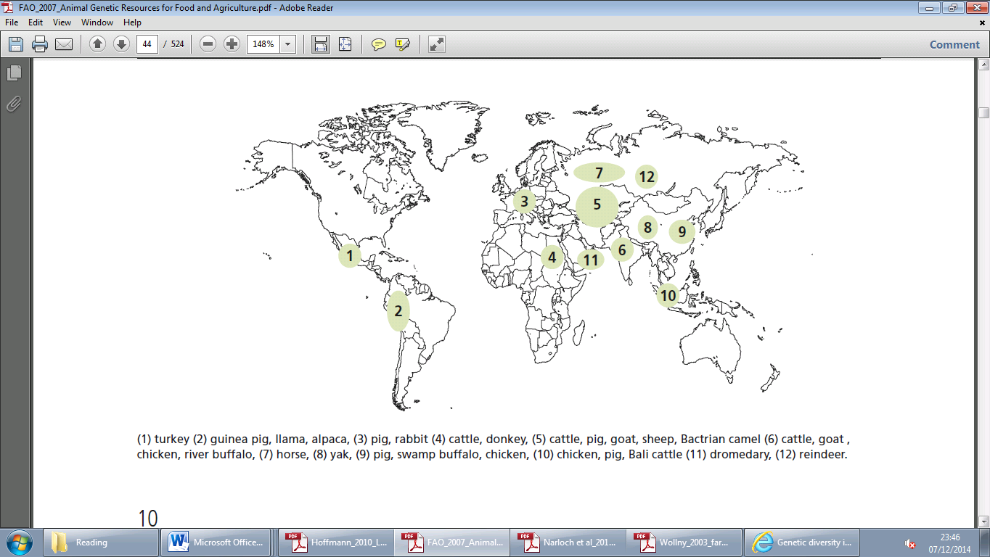

**Figure 2:** Major centres of livestock domestication (FAO, 2007)

The definition of a breed is contested, but in its simplest terms it refers to a recognised group of interbreeding animals of a given species. Animals belonging to the same breed are usually of fairly uniform appearance which distinguishes them from other breeds (Villanueva et al., 2004).

The global distribution of breed diversity is heterogeneous (Figure x). Specifically, Asia, Europe, the USA, Brazil and India contain high levels of breed diversity. Some 70% of livestock breeds are found in developing countries (Drucker et al., 2001).

* Define FAnGR – what are they. Where are they most prolific?
* Brief history of FAnGR including domestication centres
* Recent history of FAnGR including selective breeding under Robert Bakewell and technological advances in farm animal breeding

### Overview of Plant Genetic Resources (PGR)



**Figure 3:** Major centres of livestock domestication

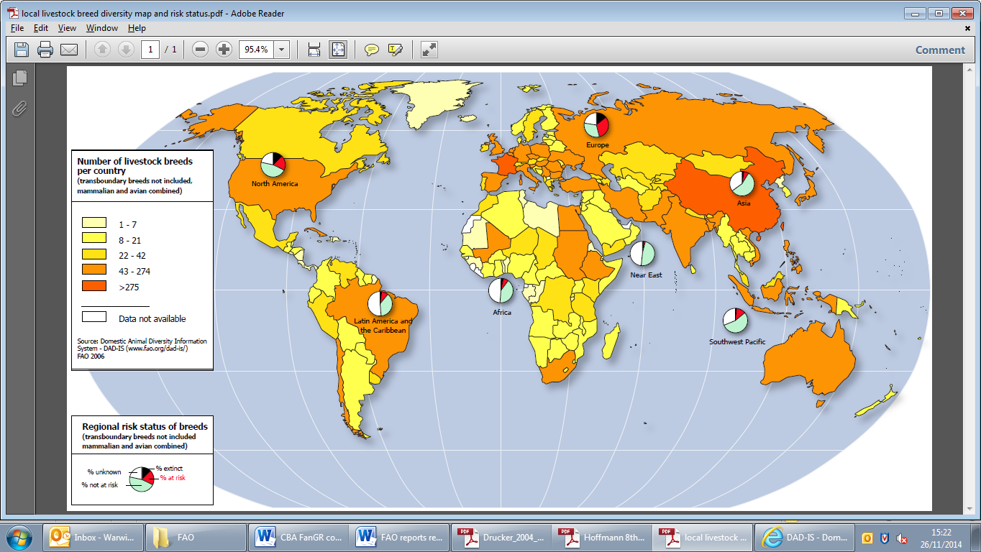

**Figure 4:** Distribution of the world’s FAnGR and regional risk status of breeds

## The importance of PGR and FAnGR

### FAnGR

Livestock also are used for ploughing and transport,

provide a local supply of manure, can be a

vital source of income, and are of huge cultural

importance for many poorer communities. Godfray et al 2010

## The state of PGR and FAnGR globally

### Threats and pressures

## Aims and objectives

## Structure of the thesis

# Valuing rare livestock breeds and farm animal genetic diversity: preferences, institutions and prospects

The chapter focuses on the distinction between ‘rare breeds’ and FAnGR more generally. Highlighting the links between FAnGR and the sustainable intensification (SI) agenda, we discuss the prioritisation of efficiency objectives in the food system (and associated supply chains) over culture and heritage values. Drawing on the latter, we link this example to the case of rare breeds which often possess attributes of value not linked to production efficiency. The chapter concludes with wider discussion concerning three potential threats to rare breeds; SI, climate change and disease events. But opportunities for rare breeds, in the form of new production and market opportunities, are also discussed in the form of these three issues.

Chapter type: Review chapter

Completeness: 90%

Expected completion date: June 2017

# Contracts for supplying Farm Animal Genetic Resources (FAnGR) conservation services in Romania

The chapter explores the barriers to participate in rare breed conservation programmes for farmers in small scale systems in Romania. We use a choice experiment (CE) to determine attributes of a conservation contract that may be less or more desirable from a farmer perspective whilst also measuring WTA conservation subsides. The former are used to inform the design of contracts whilst the latter are contrasted with subsidy payment rates (Euro/head livestock/year) proposed by the EU for keeping rare breeds. We outline the probability of contractual enrolment among different farmer groups and suggest options for improving farmer uptake. The chapter discusses the importance of embedding FAnGR conservation in other policy measures linked to wider rural development policy, such as those targeting preservation of traditional agricultural systems.

Chapter type: Empirical work

Completeness: 80%

Expected completion date: Sept 2017

# Economic costs for in-situ conservation of Crop Wild Relatives (CWR) in Zambia: An application of Competitive Tender (CT)

The chapter identifies the lack of robust economic estimates concerning the costs surrounding in-situ CWR conservation. We discuss the cost implications of using different Area management options (AMOs) for conservation services and how the ‘mix’ of these might lead to fundamentally different conservation outcomes (i.e. species and diversity) and costs. The article moves to discuss the resource requirements should a national *in-situ* CWR conservation strategy be implemented in Zambia. The article concludes with a summary of wider deliberation concerning the use of PES including equitability and cost effectiveness considerations.

Chapter type: Empirical work

Completeness: 60%

Expected completion date: November 2017

# Developing a prioritisation metric for conserving cattle native breeds at risk (NBAR) in the UK

Prioritisation measures and indicators currently developed to inform FAnGR conservation planning are too data intensive and specific. Consequently, there has been low/no uptake of these indicators by governments or NGO’s to inform their conservation efforts. Using multi-criteria decision analysis (MCDA) we hope to demonstrate the benefits of developing more comprehensive policy support tools to improve genetic resources conservation, using UK cattle NBAR as a case study. The MCDA will consider a set of holistic criteria including diversity, utility and endangerment to inform decision making and the use of incentives to support NBAR. The chapter will discuss some concerns raised by participants to a recent workshop, organised by SRUC, discussing the use of indicators for NBAR conservation. These concerns explicitly related to how such metrics might be used, the potential for misuse and the need for improved communication between NBAR stakeholders and government.

Chapter type: Methodological contribution

Completeness: 30%

Expected completion date: February 2018

# Conclusion and recommendations

# References

# Appendix